LWVNM Nuclear Issues Study Task 3 Report

Meeting US Electricity Needs in 2050
Jeanne Logsdon and Jim Eagle
November 2023, rev. February 2024
Task 3. Consider the current U.S. energy situation and domestic nuclear plant status including closures with related impacts on states.

Executive Summary
The Task 3 report analyzes how U.S. electricity needs can be met through 2050 while reducing greenhouse gas (GHG) emissions. DOE estimates of electricity supply and demand give evidence that renewable energy sources will provide well over half of needed supply, with the remainder primarily from declining amounts of natural gas, existing nuclear power plants, and much smaller uses of coal. Variations in current electricity sources among states and challenges to growth of renewable energy are identified. Technologies are becoming available with substantial investment to make renewables the “new baseload” energy source and to address end-of-useful-life waste issues of solar panels and wind turbines. The energy transition to renewable sources is moving ahead quickly enough that no new nuclear plants are needed to meet 2050 GHG reduction goals.

Electricity Supply and Demand Estimates to 2050
In order to meet climate goals of reducing reliance on fossil fuels for electricity generation by 2050, we need to analyze whether and how US electricity requirements can be met by other energy sources. A first step is to investigate the current and estimated demand for electricity and then identify various ways that this demand can be met. This brief report will focus on the energy mix of fossil fuels (coal and natural gas), nuclear energy, and renewable energy sources (solar and wind) in the US between now and 2050. Note that a number of assumptions must be made in all estimates of energy demand and supply, such as economic growth rates, technological advances, costs and prices, public policies, etc. Likewise, estimates of which investments in non-fossil fuel sources should be selected also depend upon a number of assumptions, which should be made transparent.
A particularly relevant, unbiased, and up-to-date source of data for estimating energy demand and supply is the US Energy Information Administration (EIA). Its Annual Energy Outlook 2023 (AEO2023) provides estimates, using 2022 as the baseline and ending in 2050. First, regarding demand, the AEO2023 estimates that increases in total demand could be as low as zero by 2050 or as high as 15% above the 2022 level. The shaded “cone of uncertainty” in the figure below (from the EIA report) takes into account various assumptions about economic growth, energy costs and availability, energy efficiency, etc. The finding that US energy demand in the residential, commercial, and transportation sectors will remain virtually unchanged in 2050 in itself is a remarkable forecast. Growth is projected to occur in the industrial sector, which also has the greatest range of uncertainty.

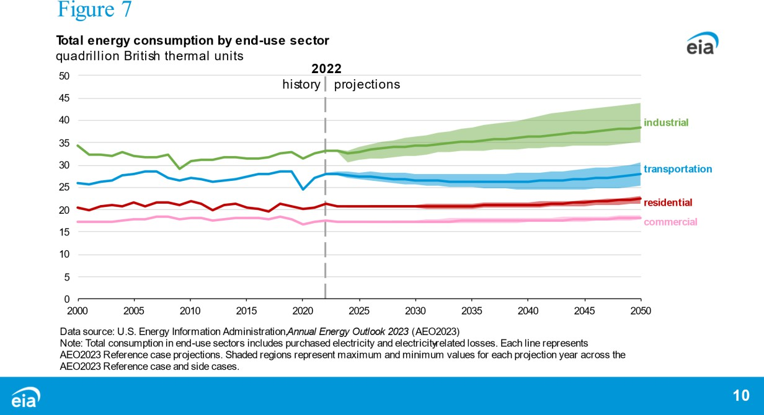

The AEO2023 also provides estimates of where the supply of energy to meet the demand will come from. The figure below tracks estimates for individual energy sources in the context of pre-2020 growth from 2010 to 2050. The reference case (bold line) estimates energy sources under current US laws and regulations (such as the Inflation Reduction Act) as they are expected
to be implemented. Note that the use of solar energy is predicted to increase dramatically. Wind energy continues to increase until the mid-2030s and then stabilizes. Natural gas and nuclear energy each exhibit small declines. Coal continues its long-term decline.
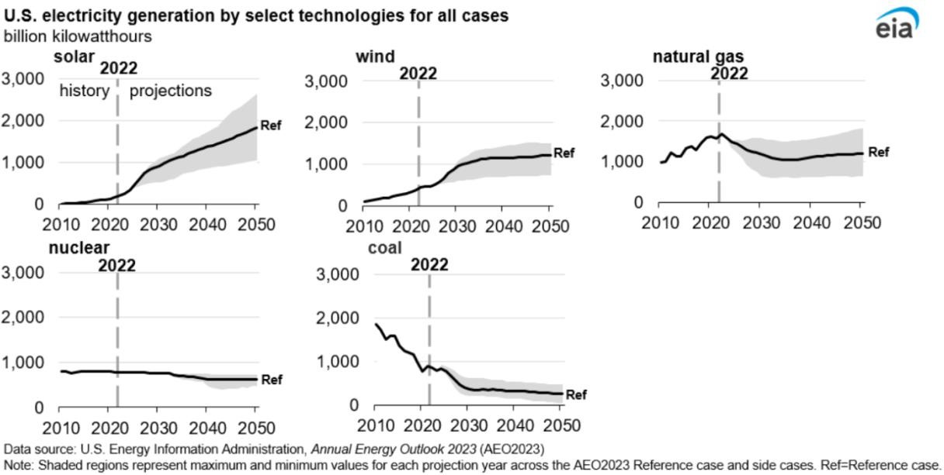

The chief reason why renewable energy sources are becoming dominant is because of declining costs relative to other sources. Between 2009 and 2021, the cost of solar dropped 90% and wind
during this period.

(See Appendix A for data on declining costs of renewables compared to traditional energy sources.)
Figure 3 below from the AEO2023 consolidates the individual estimates for each energy source into a single chart. It shows the 2022 sources of electricity in the top line and the “reference case” in the second line. The following twelve lines are the estimates of 2050 energy sources based upon various assumptions, such as low vs high oil and gas supply, low vs high renewable energy cost, low vs high economic growth, etc. In all cases, renewable sources, that is, solar and wind energy taken together, are the largest sources of energy, and coal is the lowest source by 2050. The percentage of oil and natural gas may increase or decline depending upon relative costs. Nuclear energy is declining over the period.
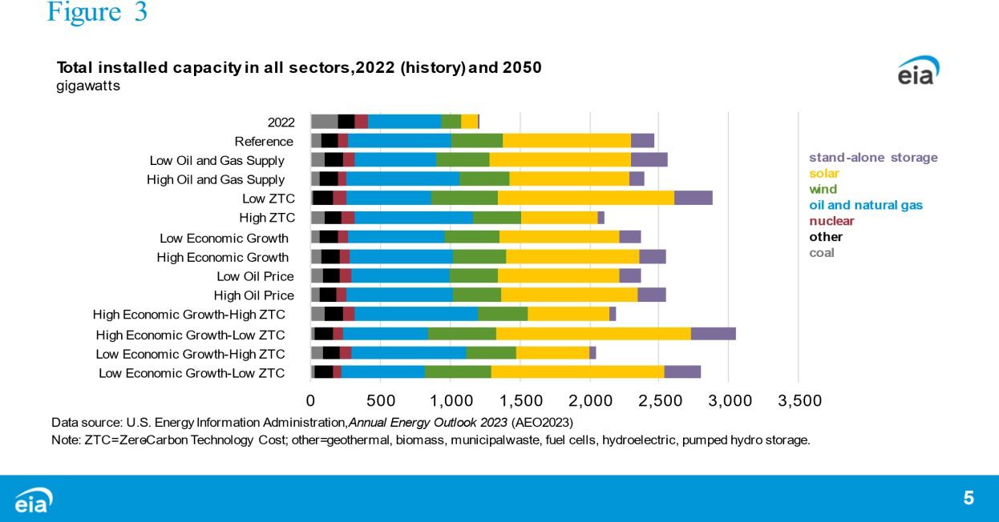
The EIA summarized its findings as follows: “In AEO2023, we see stable growth in U.S. electric power demand through 2050 in all cases we considered because of increasing electrification and ongoing economic growth. The combination of declining capital costs and government subsidies, including IRA initiatives, drive rising renewable technologies for electricity generation, such as solar and wind. Once built and when the resource is available, wind and solar are the least cost resources to operate to meet electricity demand because they have zero fuel costs. Over time, the combined investment and operating cost advantage increases the share of zero-carbon electricity generation. As a result, in AEO2023, we see renewable
generating capacity growing in all regions of the United States in all cases. Across all cases, compared with 2022, solar generating capacity grows by about 325% to 1019% by 2050, and wind generating capacity grows by about 138% to 235%. We see growth in installed battery capacity in all cases to support this growth in renewables.” ¹ (Emphasis added.) EIA thus supports the position that a mix of energy sources, including significant growth in renewables, is sufficient to meet the demand for electricity in 2050.

1 Quote from US Energy Information Administration (EIA), “Annual Energy Outlook 2023,” March 2023. https://www.eia.gov/outlooks/aeo/narrative/index.php#ExecutiveSummary

State Variability in Electricity Energy Sources
AEO2023 focuses on national estimates of energy demand and supply for electricity, but it is worthwhile to consider how the energy mix varies widely by state, due to differences in natural resource availability, relative costs and technologies when initial investment decisions were made, public policies, long-term contracts, impacts on communities, etc. Energy transitions are not smooth and automatically responsive to cost differences. Public utility investments in electricity generation are very large and long-term, and may be influenced by noneconomic considerations.
One example of how state variability might influence the pace at which fossil fuels are replaced by non-greenhouse gas energy sources relates to uses of coal. Appendix B lists the top 10 states that are currently using coal to generate electricity. Note that public utilities in West Virginia, Wyoming, and Kentucky are most dependent upon coal to generate electricity. Some state utilities on this list may choose to continue using coal because it is sourced within their state and benefits many state residents. Utilities in other states are more likely to switch to another energy source as long-term contracts expire and coal plants become obsolete if given incentives to do so or if it is otherwise less costly or preferred by citizens.
A somewhat different analysis might face the 28 states that currently have nuclear plants in operation. Appendix C lists the states with one or more reactors in the order of percentage of dependence on nuclear power in 2023. Note that Nuclear Regulatory Commission licenses to operate are initially for 40 years but may be extended in increments of 20 years if the reactor is operating safely and if requested by the state utility commission. Of the 92 US nuclear reactors operating in 2020, 88 have received an extension of 20 years on the initial 40-year license.
Appendix C shows that New Hampshire is most dependent upon nuclear energy. New Hampshire utilities generated a total of 1,520 MW-hr. of electricity, of which 59.1% came from its Seabrook nuclear plant. Seabrook has already received one extension to operate until 2050. The state’s public utility commission will have to decide in the 2040’s whether to request an additional 20-year license extension to 2070 or shift to another energy source. A possible alternative energy source might be hydroelectric energy that will be transmitted from Quebec by Avangrid’s New England Clean Energy Connect (NECEC) line.
In Appendix C Illinois has the second highest dependence on nuclear energy at 55.6%. After 11 reactors were built in the 1970s and 1980s, its legislature passed a very restrictive requirement in 1987 against building any new nuclear facilities, one of twelve states that have such bans or restrictions.² However, conflicts have arisen in recent years in Illinois about whether to continue to rely on nuclear energy by lifting the restrictions. The state legislature passed a bill in 2023 that would have repealed the state’s law banning the construction of new nuclear facilities until a permanent site for nuclear waste disposal is selected. However, the Illinois governor vetoed the legislation. Meanwhile, its nuclear utility is applying to extend the licenses of two plants to operate into the 2040s.
While most states with nuclear facilities have opted to extend their licenses to operate for at least 20 years, ten states chose to permanently close 12 U.S. nuclear reactors between 2013 and 2021,

2 According to the National Conference of State Legislatures website, the 12 states with bans or strong restrictions on new nuclear power plants are: California, Connecticut, Hawaii, Illinois, Maine, Massachusetts, Minnesota, New Jersey, New York, Oregon, Rhode Island, and Vermont. https://www.ncsl.org/environment-and-natural-resources/states-restrictions-on-new- nuclear-power-f

according to a Congressional Research Service (CRS) report in 2021. (See Appendix D for a list of these shutdowns.) Seven other reactor retirements were announced through 2025. However, the CRS report notes that announced retirements have not always occurred as planned because states may take actions to provide more revenues to keep a plant operating. Many other U.S. reactors have been identified by recent studies as being “at risk” of shutdown for economic reasons, although their closures have not been announced.³
It appears that growth in new nuclear power plants is unlikely at the present time. The strategy in most cases is to keep existing nuclear plants in operation when safe to do so and cost-effective compared to alternatives.

Renewable Energy Challenges

Many scholars assert that the U.S. can become 100% reliant on renewable energy sources in the foreseeable future (e.g., Jacobson, et al., 2017; Jacobson, 2023), but acknowledge that a number of technical and non-technical challenges to renewable energy growth must be addressed. (See Breyer, et al., for a review of scholarly research on 100% renewable energy opportunities and challenges, beginning in the 1970s and growing substantially since 2014. This extensive analysis has 472 references.) Recently, academic and business research articles (e.g., Wouters, 2023; McKinsey & Company, 2022) have claimed that renewable energy is becoming the “new baseload,” refuting an argument against reliance on solar and wind energy. “The Baseload Fallacy” (Wouters, 2023) identifies ways that variability in solar and wind power generation can be managed to provide electricity 24/7, including interconnecting existing regional power grids; demand management; and energy storage.
The 2021 study by the U.S. Department of Energy's (DOE's) National Renewable Energy Laboratory (NREL) and DOE's Office of Energy Efficiency and Renewable Energy (EERE) concluded that current technical knowledge was sufficient to achieve up to 80% reliance on renewable energy sources. This study (called the NREL-EERE study below) divided the technical problems in the transition to 100% renewable energy into 3 categories, as shown in NREL-EERE’s graphic below.
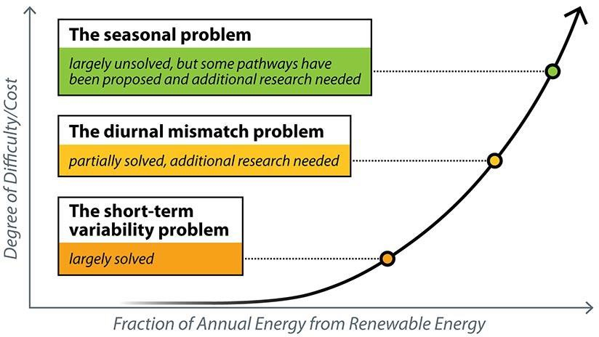
The short-term variability problem relates to the public utility balancing the supply of renewable energy and demand for electricity on a minute-by-minute basis. This problem is largely solved, according to the NREL-EERE study. Studies of the second problem, called the diurnal mismatch problem, focus on balancing supply and demand over a 24-hour period because peak demand occurs at night but supply of solar and wind energy is mostly generated during the day. Battery storage systems are key to solving this problem. The NREL-EERE study claims that battery

3 Quote from Congressional Research Service (CRS), “U.S. Nuclear Plant Shutdowns, State Interventions, and Policy Concerns,” June 10, 2021. https://crsreports.congress.gov R46820.

technology is currently sufficient to achieve up to 80% of electricity demand using renewable energy sources.
In the third zone, however, the seasonal mismatch problem needs research to “evaluate the suite of technologies that can help ensure renewable supply matches demand patterns across all time periods—and that we will need significant engineering and design to transition the grid from one that is dependent on synchronous machines to one that is based on inverters.”⁴
The non-technical problems in transitioning to renewable energy are economic, environmental, social, and political. They include the following issues:
- Large investments necessary for electrical grid expansion and upgrades. (That is, more transmission lines to connect solar and wind sources to end users and to update existing transmission lines to integrate renewable sources).
- Creation of recycling facilities for solar panels and wind turbines.
- Local opposition to large solar and wind installations based upon land use and environmental issues, such as impacts on wildlife.
- Very long permitting times for some renewable energy projects, which relate in part to the local opposition issue above. (For example, Pattern Energy’s SunZia transmission line in New Mexico, the largest wind energy project in the Western Hemisphere as of 2023, took 17 years to be approved.)
- Worker and community exposures to hazardous amounts of lead, lithium, tin, and cadmium used in manufacturing solar and wind equipment.
- Supply chain issues, including availability of critical but scarce minerals and materials. (See Breyer, et al., 2022, Section VI, Part D for a detailed analysis of this issue.)
- Opposition by other energy interest groups.
Perhaps one of the easier issues to solve is modernizing the electrical power grid because we have been working on it since at least 2015. The DOE prepared a comprehensive multi-year plan to modernize the electrical power grid nation-wide in November 2015. The Pacific Northwest National Laboratory is taking responsibility for researching “renewable integration.” Much of the early work is on research to identify low-cost technical solutions that could be implemented at state and local levels.
Subsequently state-level actions to modernize the power grid have been extensive as reported by the National Council of State Legislatures. Its 2021 report stated: “Legislatures, public utility commissions and energy providers across the nation are discussing grid modernization, assessing needs, policies, costs and return on investment. While needs vary from state to state, the latest report from the American Society for Civil Engineers found that current grid investment trends will lead to funding gaps of $42 billion for transmission and $94 billion for distribution by 2025… Although many of these upgrades may require significant investment, many can result in operational savings while providing resiliency and other benefits. Technologies that increase knowledge of grid operations, for instance, can allow utilities to better balance fluctuating supply and demand, respond to outages, optimize resource use and increase efficiency.”⁵ At least $378 billion in federal grants, loans, and tax credits for grid modernization and wind energy projects

4 The “inverter problem” is described in the NREL-EERE study. An inverter converts direct current (DC) electricity, which is what a solar panel generates and battery systems produce, to alternating current (AC) electricity, which the electrical grid uses. With DC, electricity is maintained at constant voltage in one direction. With AC, electricity cycles in both directions in the circuit. See EERE’s website for a description of inverters. https://www.energy.gov/eere/solar/solar-integration-inverters-and-grid-services- basics#:~:text=Traditional%20%E2%80%9Cgrid%2Dfollowing%E2%80%9D%20inverters,the%20inverter%20tries%20to%20match

5 Source for quote: National Council of State Legislatures, “Modernizing the Electric Grid: State Role and Policy Options.” Updated September 22, 2021. https://www.ncsl.org/energy/modernizing-the-electric-grid

have been announced by the Department of Energy. Other federal agencies also have clean energy funding available.
The second problem relates to recycling the large amount of worn out solar panels and wind turbines, which have useful lives of about 20 to 30 years. While 28 recycling facilities already exist for solar panels, many more will be needed to process the 95% of solar panels that can be recycled with existing technology. The Environmental Protection Agency is funding studies to extract silver and lead and to refine silicon in order to design a “circular economy” for renewable energy materials. Progress to recycle wind turbines is also being made by DOE’s Wind Energy Technologies Office.
The other issues are challenges to be addressed on a case-by-case basis. Each state has particular circumstances that influence support for or opposition to renewable energy sources. Appendix E shows the percentage of renewable energy generated in each state in November 2023. The contrast between the top 10 states and the bottom 10 is stark. Seven states are already above 50% usage of renewable energy, while six states use 5% or less. The midpoint is only 14%.
Clearly, there is much room to increase use of renewable sources, and funding is available to expedite this growth.

Conclusions
The U.S. Energy Information Administration’s AEO2023 states that it is technically feasible to rely on a mix of energy sources to meet both the predicted demand for electricity in 2050 and also net-zero climate goals. Solar and wind energy sources will provide over 50% of supply with substantial funding at the federal and state levels. Existing nuclear energy will continue to provide electricity with plants in operation today whose useful lives have been extended 20 to 40 years beyond initial licenses. The balance of supply will come from natural gas to a large extent and from coal at a much lower extent than in the past.
Achieving the goal of 100% renewable energy requires overcoming a number of challenges. Leading states are showing the way in how to overcome these challenges. The general public is strongly in favor of developing solar and wind energy projects. (See Appendix F for a 2022 Pew survey question comparing public opinions about renewable vs. nuclear energy projects.) Many states are well on the way to investing in infrastructure to support solar and wind energy projects. In our view, the energy transition to renewables is moving ahead quickly enough that no new nuclear plants are needed to meet 2050 goals.

Appendix A
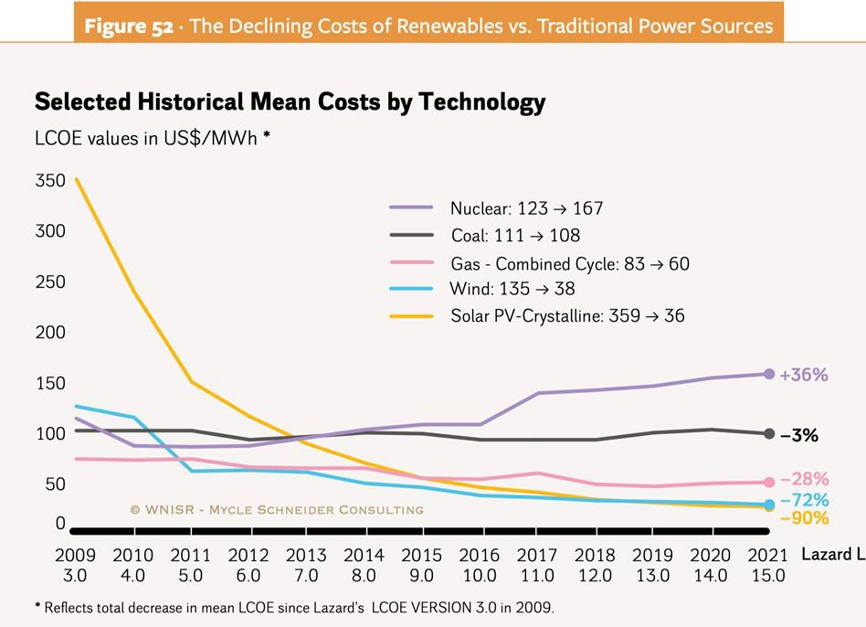
Source: World Nuclear Industry Status Report 2022, page 280 https://www.worldnuclearreport.org/IMG/pdf/wnisr2022-figure52_lazard_lcoe_2021.pdf

Appendix B

Top 10 states using coal to generate electricity in 2023*:
West Virginia | 83.9% | Nebraska | 50.7%
Wyoming | 75.1% | Utah | 44.7%
Kentucky | 69.0% | Indiana | 43.8%
Missouri | 64.7% | Montana | 39.8%
North Dakota | 60.0% | Iowa | 37.4%
*Data are extracted from https://www.chooseenergy.com/data-center/electricity-sources-by-state/. The website provides state-by-state data of energy sources as well as lists of the top 10 states using 5 energy sources.

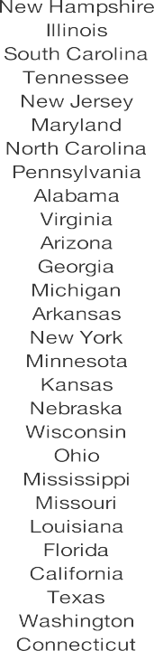
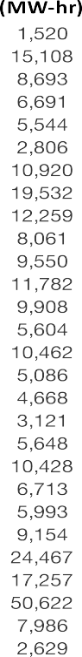
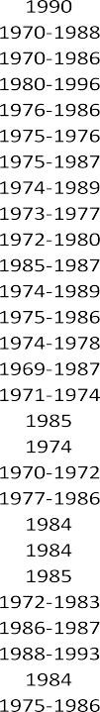
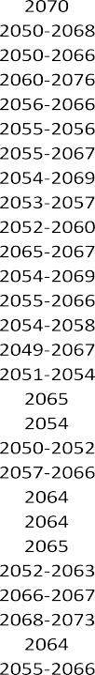
Appendix C

Nuclear Energy Dependence by State, Generation, No. of Reactors, and Potential Lifespan*

*Sources: Choose Energy, https://www.chooseenergy.com/data-center/electricity-sources-by- state/;
US Energy Information Administration, https://www.eia.gov; Nuclear Regulatory Commission https://www.nrc.gov/reactors/operating/licensing/renewal/applications.html; Office of Nuclear Energy, https://www.energy.gov/ne/office-nuclear-energy

Appendix D

U.S. Nuclear Reactor Shutdowns, 2013-2021*

State | Reactor | Start-up Year | Shutdown Date | Generating Capacity (Megawatts) | Major Factor(s) Contributing to Shutdown
Florida | Crystal River 3 | 1977 | Feb. 2013 | 860 | Cost of major repairs to reactor containment
Wisconsin | Kewaunee | 1974 | May 2013 | 566 | Operating losses
California | San Onofre 2 | 1983 | June 2013 | 1,070 | Cost of replacing
 |  |  |  |  | defective steam
 |  |  |  |  | generators
California | San Onofre 3 | 1984 | June 2013 | 1,080 | Cost of replacing
 |  |  |  |  | defective steam
 |  |  |  |  | generators
Vermont | Vermont | 1972 | Dec. 2014 | 620 | Operating losses
 | Yankee
Nebraska | Fort Calhoun | 1973 | Oct. 2016 | 479 | Operating losses
New Jersey | Oyster Creek | 1969 | Sept. 2018 | 614 | Agreement with state
 |  |  |  |  | to avoid building
 |  |  |  |  | cooling towers
Massachusetts | Pilgrim | 1972 | May 2019 | 685 | Operating losses; rising
 |  |  |  |  | capital expenditures
Pennsylvania | Three Mile | 1974 | Oct. 2019 | 803 | Operating losses
 | Island I
New York | Indian Point 2 | 1974 | Apr. 2020 | 1,020 | Low electricity prices;
 |  |  |  |  | settlement with state
Iowa | Duane Arnold | 1975 | Aug. 2020 | 601 | Lower-cost alternative
 |  |  |  |  | power purchases
New York | Indian Point 3 | 1976 | Apr. 2021 | 1,038 | Low electricity prices;
 |  |  |  |  | settlement with state

*Source: Adapted from Table 1, Congressional Research Service. U.S. Nuclear Plant Shutdowns, State Interventions, and Policy Concerns. June 10, 2021. https://crsreports.congress.gov R46820.

Appendix E

Renewable Energy Use by State, November 2023*

State | % Renewable  Sources (11/23) |  | % Solar | % Wind | Hydroelectric
1. Vermont | 95.3 |  | 25.0 | 16.0 | 54.3
2. Washington | 65.8 |  | 1.2 | 5.7 | 58.9
3. South Dakota | 64.1 |  | 0 | 44.6 | 19.5
4. Idaho | 59.9 |  | 9.1 | 10.5 | 40.3
5. Maine | 57.0 |  | 13.3 | 16.4 | 27.3
6. Oregon | 55.3 |  | 5.3 | 14.6 | 35.4
7. California | 50.5 |  | 31.4 | 5.0 | 14.1
8. Montana | 46.3 |  | 2.3 | 13.4 | 30.6
9. Iowa | 40.9 |  | 1.7 | 38.2 | 1.0
10. New Mexico | 38.9 |  | 10.2 | 28.7 | 0
11. Massachusetts | 38.1 |  | 33.1 | 0.8 | 4.2
12. Colorado | 35.1 |  | 11.1 | 22.0 | 2.0
13. Hawaii | 32.4 |  | 24.8 | 7.6 | 0
14. North Dakota | 31.8 |  | 0 | 28.1 | 3.7
15. Kansas | 30.7 |  | 0.4 | 30.3 | 0
16. Nevada | 30.3 |  | 27.3 | 0.5 | 2.5
17. New York | 28.9 |  | 5.9 | 2.9 | 20.1
18. Oklahoma | 28.4 |  | 0.3 | 26.5 | 1.6
19. Minnesota | 22.7 |  | 4.6 | 17.0 | 1.1
20. Nebraska | 22.7 |  | 0.4 | 20.4 | 1.9
21. Texas | 21.4 |  | 6.3 | 15.0 | 0.1
22. Alaska | 18.6 |  | 0 | 0 | 18.6
23. Wyoming | 14.7 |  | 0.5 | 13.0 | 1.2
24. Utah | 14.2 |  | 13.1 | 1.1 | 0
25. Rhode Island | 14.0 |  | 12.7 | 1.3 | 0
26. North Carolina | 12.4 |  | 9.2 | 0.2 | 3.0
27. Tennessee | 11.9 |  | 1.5 | 0 | 10.4
28. Maryland | 11.2 |  | 6.9 | 0.7 | 3.6
29. Illinois | 9.5 |  | 2.3 | 7.1 | 0.1
30. New Hampshire | 9.4 |  | 0 | 2.1 | 7.3
31. Indiana | 9.0 |  | 3.3 | 5.3 | 0.4
32. Missouri | 8.6 |  | 1.4 | 5.5 | 1.7
33. New Jersey | 8.1 |  | 8.1 | 0 | 0
34. Kentucky | 7.7 |  | 0.5 | 0 | 7.2
35. Virginia | 7.5 |  | 6.4 | 0 | 1.1
36. Michigan | 7.0 |  | 1.6 | 4.6 | 0.8
37. Arkansas | 6.3 |  | 1.8 | 0 | 4.5
38. Delaware | 6.2 |  | 6.2 | 0 | 0
39. Alabama | 6.1 |  | 0 | 0 | 6.1
40. Arizona | 6.1 |  | 0 | 1.4 | 4.7
41. Florida | 6.1 |  | 6.1 | 0 | 0
42. Georgia | 5.9 |  | 5.9 | 0 | 0
43. Wisconsin | 5.9 |  | 2.6 | 1.4 | 1.9
44. South Carolina | 5.6 |  | 3.6 | 0 | 2.0
45. Connecticut | 5.0 |  | 4.3 | 0 | 0.7
46. West Virginia | 5.0 |  | 0.1 | 2.2 | 2.7
47. Ohio | 3.1 |  | 1.7 | 1.1 | 0.3
48. Pennsylvania | 2.5 |  | 0.7 | 0.8 | 1.0
49. Louisiana | 1.3 |  | 0.5 | 0 | 0.8
50. Mississippi | 0.9 |  | 0.9 | 0 | 0
*Source: Adapted from https://www.chooseenergy.com/data-center/electricity-sources-by-state/, November 2023.

Appendix F
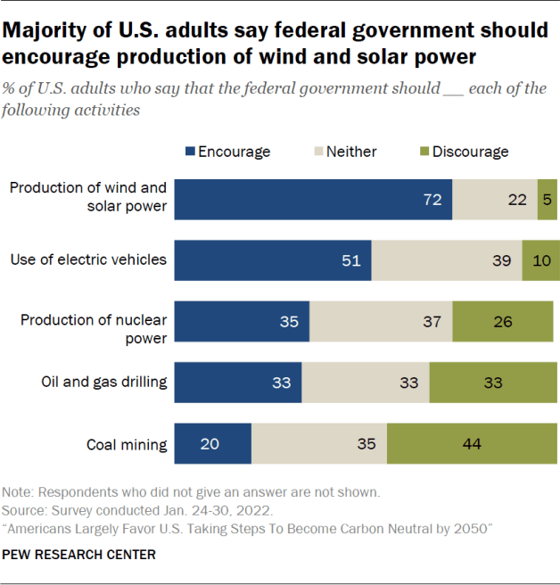

References
Works cited in Task 3 Report are noted with an asterisk (*). Other references were consulted as background.

bp. “bp Energy Outlook – 2023 Edition. https://www.bp.com/content/dam/bp/business- sites/en/global/corporate/pdfs/energy-economics/energy-outlook/bp-energy-outlook-2023.pdf. BP’s research predictions for 2050. “The future of global energy is dominated by four trends: declining role for hydrocarbons, rapid expansion in renewables, increasing electrification, and growing use of low-carbon hydrogen.” No specific mention of nuclear.
*Breyer, C., et al. "On the History and Future of 100% Renewable Energy Systems Research."
IEEE Access, 2022(10): 78176-78218, 2022, doi: 10.1109/ACCESS.2022.3193402. Available at
https://ieeexplore.ieee.org/abstract/document/9837910. Technical analysis and description of hundreds of academic articles on 100% renewable energy since the mid-1970s.

Canary Media. “Chart [of the Week]: Clean energy to make up 84% of new US power capacity in 2023.” March 10, 2023. By Julian Spector & Maria Virginia Olano. https://www.canarymedia.com/articles/clean-energy/chart-clean-energy-to-make-up-84-of-new- us-power-capacity-in-2023. Investment rates of non-renewables in 2023: 84% of new investments. Good quote: “Notably, the power plants arriving this year were developed before the passage of the Inflation Reduction Act last year. Clean energy was sweeping the industry even before Congress allocated $369 billion to encourage its adoption. Armed with the incentives in that law, clean energy portfolios are expected to be cheaper than nearly every new gas plant planned for construction through 2035, according to a recent analysis.” [emphasis added]
Capitol News Illinois. “Nuclear Option: Illinois Grapples with the Future of Nuclear Power.” March 17, 2023. By Andrew Adams. https://capitolnewsillinois.com/NEWS/nuclear-option- illinois-grapples-with-the-future-of-nuclear-power. Detailed report on recent developments in Illinois about continuing to rely on nuclear energy.

*Choose Energy website. https://www.chooseenergy.com/data-center/electricity-sources-by- state/. Note remarkable differences by state in the energy mix to generate electricity. Data-rich source.
*Congressional Research Service. “U.S. Nuclear Plant Shutdowns, State Interventions, and Policy Concerns.” June 10, 2021. https://crsreports.congress.gov R46820.
ExxonMobil. “Global Outlook Report: Energy Demand.” August 28, 2023. https://corporate.exxonmobil.com/what-we-do/energy-supply/global-outlook/energy- demand#Electricityandpowergeneration. Exxon’s estimates for 2050. Wind and solar expected to reach 50%. Little or no growth predicted for nuclear energy except in China.
International Energy Association. “Nuclear Power in a Clean Energy System.” May 2019. https://www.iea.org/reports/nuclear-power-in-a-clean-energy-system. Note section on “Lifetime extensions of nuclear power plants are crucial to getting the energy transition back on track.”

*Jacobson, M.Z. No Miracles Needed. University Printing House, Cambridge CB2 8BS, United Kingdom, 2023.
*Jacobson, M.Z., et al. “The United States can keep the grid stable at low cost with 100% clean, renewable energy in all sectors despite inaccurate claims.” Proceedings of the National Academy of Sciences of the United States of America. 2017; 114 (26): E5021-E5023.
Jacobson, M.Z., et al. “Low-Cost Solutions to Global Warming, Air Pollution, and Energy Insecurity for 145 Countries.” Energy & Environmental Science, 2022, 15: 3343-3359. Available at https://web.stanford.edu/group/efmh/jacobson/Articles/I/145Country/22-145Countries.pdf.
*McKinsey & Company. “Renewables become the new baseload.” 2022 Global Energy Perspective.
*National Council of State Legislatures. “Modernizing the Electric Grid: State Role and Policy Options.” Updated September 22, 2021. By Glen Andersen, Megan Cleveland, and Daniel Shea. https://www.ncsl.org/energy/modernizing-the-electric-grid. 2021 report on state initiatives to modernize the electrical power grid. Reference made to renewable energy standards that are increasingly being mandated by state legislatures.
*National Council of State Legislatures. “States’ Restrictions on New Nuclear Power Facility Construction.” Updated September 28, 2023. https://www.ncsl.org/environment-and-natural- resources/states-restrictions-on-new-nuclear-power-facility-construction.

*Pacific Northwest National Laboratory. “Renewable integration.” https://www.pnnl.gov/explainer-articles/renewable-integration
*Pew Trusts. “New Federal Funding Accelerates America’s Clean Energy Future.” April 21, 2023. By Laura Lightbody & Brian Watts. https://www.pewtrusts.org/en/research-and- analysis/articles/2023/04/21/new-federal-funding-accelerates-americas-clean-energy-future.Very substantial federal funding opportunities for the energy transition, including funding for grid modernization to states and tribes.
Popovich, N. & Plumer, B. “Why the U.S. Electric Grid Isn’t Ready for the Energy Transition.” New York Times, June 12, 2023. https://www.nytimes.com/interactive/2023/06/12/climate/us- electric-grid-energy-transition.html. Continuing challenges to creating macro-grids that could transport energy across state lines in order to balance supply and demand. Need for nation-wide planning, rather than rely on current regional grids.
Resources for the Future. “Global Energy Outlook 2023: Sowing the seeds of an energy transition.” March 2023. By Raimi, Zhu, Newell, Prest, & Bergman. Available at https://www.rff.org/publications/reports/global-energy-outlook-2023/. Scholars from Resources for the Future, a nonpartisan research and public policy organization, analyze 15 studies that estimate global and regional energy demand and various pathways to achieve reductions in greenhouse gas emissions.
Rocky Mountain Institute. “Reality Check: The IEA Busts 10 Myths about the Energy Transition.” September 29, 2023. By Kingsmill Bond & Sam Butler-Sloss. https://rmi.org/reality-check-the-iea-busts-10-myths-about-the-energy-transition/. The International Energy Agency’s latest report finds that oil demand is peaking, and renewable energy is rising.
US Department of Energy. “Grid Modernization Multi-Year Program Plan.” November 15, 2015. https://www.energy.gov/articles/grid-modernization-multi-year-program-plan-mypp. DOE’s 2015 plan for a comprehensive modernization of the electrical power grid.
*US Department of Energy. “Grid Modernization Initiative: About the Grid Modernization Initiative.” https://www.energy.gov/gmi/about-grid-modernization-initiative. DOE website about the grid modernization initiative, representing “a DOE-wide collaboration, with primary funding support coming from the Office of Electricity Delivery and Energy Reliability and Office of Energy Efficiency and Renewable Energy, and the Office of Energy Policy and Systems Analysis providing policy recommendations. DOE National Laboratories are participating across GMI’s technology areas in a coordinated strategic partnership called the Grid Modernization Lab Consortium (GMLC).”
US Department of Energy. “U.S. Department of Energy Projects Strong Growth in U.S. Wind Power Sector.” August 24, 2023. https://www.energy.gov/articles/us-department-energy-projects- strong-growth-us-wind-power-sector.
*US Department of Energy. Office of Energy Efficiency and Renewable Energy (EERE). “Solar Integration: Inverters and Grid Services Basics.” https://www.energy.gov/eere/solar/solar- integration-inverters-and-grid-services- basics#:~:text=Traditional%20%E2%80%9Cgrid%2Dfollowing%E2%80%9D%20inverters,the
%20inverter%20tries%20to%20match.
US Department of Energy. National Renewable Energy Laboratory (NREL). “At a Glance: How Renewable Energy Is Transforming the Global Electricity Supply.” September 26, 2023. By Harrison Dreves. https://www.nrel.gov/news/program/2023/how-renewable-energy-is- transforming-the-global-electricity-supply.html. Rapid recent growth of renewables means that we cannot extrapolate future supply from past energy data (pre-2020).
*US Department of Energy. National Renewable Energy Laboratory (NREL). “What We Know—and Do Not Know—About Achieving a National-Scale 100% Renewable Electric Grid.” May 19, 2021. By Devonie McCamey. https://www.nrel.gov/news/features/2021/what-we-know- and-dont-know-about-achieving-a-national-scale-100-renewable-electric- grid.html#:~:text=Within%20this%20framework%2C%20the%20paper,and%20stable%20grids
%20using%20largely. DOE's National Renewable Energy Laboratory (NREL) and Office of Energy Efficiency and Renewable Energy (EERE) provide an analysis of the technical challenges to reach 100% renewable energy in the US. Problems are grouped into 3 increments, two of which are largely solved.
US Department of Energy. Office of Nuclear Energy. “What's the Lifespan for a Nuclear Reactor? Much Longer Than You Might Think.” April 16, 2020. https://www.energy.gov/ne/articles/whats-lifespan-nuclear-reactor-much-longer-you-might-think.

*US Department of Energy. Wind Energy Technologies Office. “No time to waste: A circular economy strategy for wind energy.” R&D Newsletter, Spring 2021. (June 2, 2021).
https://www.energy.gov/eere/wind/articles/no-time-waste-circular-economy-strategy-wind-energy

*US Department of Energy. Wind Energy Technologies Office. “Carbon rivers makes wind turbine blade recycling and upcycling a reality with support from DOE.” (October 17, 2022). https://www.energy.gov/eere/wind/articles/carbon-rivers-makes-wind-turbine-blade-recycling-and-upcycling-reality-support.

*US Energy Information Administration (EIA). “Annual Energy Outlook 2023.” March 2023. https://www.eia.gov/outlooks/aeo/narrative/index.php#ExecutiveSummary. Excellent source of up-to-date information about energy supply and demand to 2050.
*US Environmental Protection Agency. “End-of-life management of photovoltaic solar panels in the United States.” May 1, 2023.
*US Environmental Protection Agency. “Renewable energy management: Solar panel recycling.” By E. S. Demessie, September 27, 2023.
*US Nuclear Regulatory Commission. “Status of Initial License Renewal Applications and Industry Initiatives.” https://www.nrc.gov/reactors/operating/licensing/renewal/applications.html.
Utility Dive. “In win for Avangrid, FERC orders NextEra to install Seabrook circuit breaker, opening path for NECEC line.” February 3, 2023. By Ethan Howland. https://www.utilitydive.com/news/-avangrid-ferc-nextera-seabrook-necec-transmission/641928/. FERC decision that New Hampshire’s Seabrook nuclear plant must install a circuit breaker so that Avangrid’s transmission line to Quebec hydroelectric power can be safely connected.
“World Nuclear Industry Status Report 2022.” https://www.worldnuclearreport.org/IMG/pdf/wnisr2022figure52_lazard_lcoe_2021.pdf.
*Wouters, F. “The baseload fallacy.” Energy Global, August 2, 2023.

