LWVNM Nuclear Issues Study Report 2024
Karen M. Douglas, John Loughead
Task 1. Summarize the current contribution nuclear energy provides as both a baseload and a greenhouse gas-free (GHG-free) source for domestic/international energy production (In August 2023 the Task Leaders recommended a comparison of all GHG-free sources).

Contents
- Introduction
- Greenhouse Gas-Free Energy Sources
- Factors Impacting Energy Delivery
- Regional Availability of Renewable Energy Sources
- Grid-Level Cost Comparison of Energy Sources
- Land Use Comparison of Energy Sources
- Life Cycle Greenhouse Gas Emission Comparisons from Electricity Generation
- Current Discussion of Nuclear Energy’s Role in Greenhouse Gas Emission Reductions

- Introduction
The power sector is the largest carbon dioxide emitter, making up more than 40% of global emissions, followed by the transport and industry sectors, which each produce around 25% of global emissions (IEA, 2021a). Some models forecast total electricity demand will increase by 250% between 2020 and 2050, while energy efficiency improves at a rate of 4% per year^{. (1)} As electricity demand continues to rise, greenhouse gas (GHG) emissions must fall if we are to mitigate climate change, and we must switch to cleaner sources to reduce air pollution. This will require large increases of all low-carbon energy sources, of which nuclear is an important part.
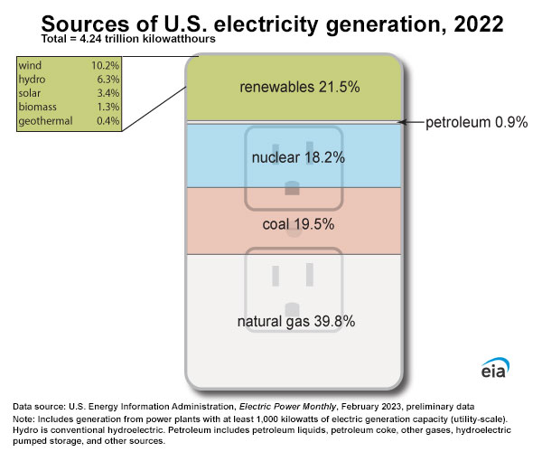
- Greenhouse Gas-Free Energy Sources
The current international energy mix includes both Baseload and Renewable/Variable Energy Sources. Baseload power sources operate continuously to meet the minimum level of power demand at all times. Baseload plants are usually large-scale and are key components of an efficient electric grid. They produce power at a constant rate and are not designed to respond to peak demands or emergencies.
- Clean Baseload Energy – Baseload power generation can be produced from both renewable (geothermal, hydropower, heat, biomass, biogas, where available) or non-renewable resources (nuclear or fossil-fuel).
- Clean Variable/Renewable Energy may harness energy from natural sources that are continually replenished, for example, from the sun (solar energy), the wind (wind energy), plants (bioenergy), rainfall (hydropower), or even the ocean.⁽³⁾ Domestic renewable energy sources are depicted below:

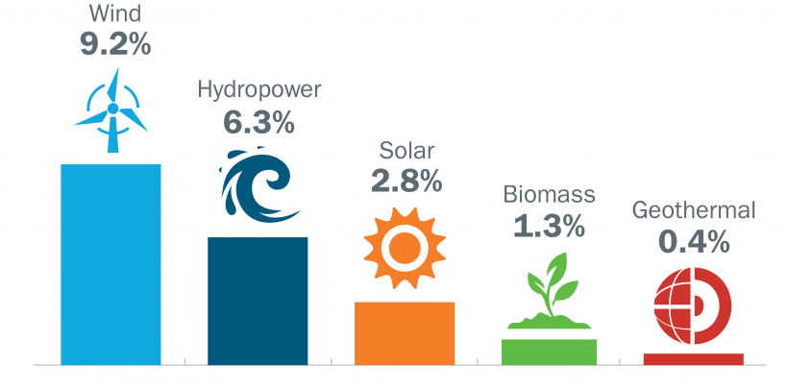 Renewable Energy | Department of Energy
Greenhouse gas-free energy sources —nuclear, hydropower, wind, solar, and more— are currently responsible for approximately 40% of the nation’s electricity supply. Commercial nuclear power provides 56% of the GHG-free power in the U.S. Wind and solar generation are growing rapidly; nevertheless, nuclear and hydropower provide almost two-thirds of the clean electricity generation and are the primary source of the clean electricity baseload. Nuclear plants, in particular, regularly operate for more than 90% of the year and can provide electricity in extreme situations when other resources may not be available.⁽²⁾
Clean generation sources including nuclear energy and hydropower must continue operations to meet climate change goals, including lifetime extensions/license renewals for operating nuclear power plants. Storage technologies under development will soon contribute to renewable/variable energy sources’ value in lowering carbon emissions but these structures for renewable energy sources will subsequently require refurbishment for continued operation.

Variable/Renewable Energy Sources

Solar
Solar energy panels that can convert the power of the sun to electrical energy have existed for several decades, but dramatic cost reductions and rapid market growth for residential installations have made this an option for utilities over the past ten years. Photovoltaic panels can be installed as arrays of surface mounted units or on rooftops to convert solar energy to electrical power to be used locally or fed to the existing electrical power grid for use by others. The technology is relatively mature and has relatively low capital and maintenance costs. The time to install a solar system is generally the shortest of all GHG-Free energy technologies and can be implemented in about one to three months. Larger arrays may require additional time to verify compatibility with grid interface needs but can be implemented in about a year unless modifications to the grid connection are not standard.

Wind
Harnessing the power of the wind and converting it to electrical power is another technology that has become more prevalent and visible over the past decade. This technology is being installed in many areas of the country in clusters of windmills. Except for marine and off-grid homestead uses, this technology is not installed on residences or in higher density urban settings and has a higher capital cost than solar arrays. The systems require a dedicated connection to the electrical power grid but can be installed on land used for compatible purposes such as agriculture or ranching.
- Major Baseload Energy Sources

Nuclear
“Nuclear energy supplies approximately 10% of the world’s electricity and is the world’s fourth largest source of electricity, following coal, gas and hydroelectricity, which supply approximately 38%, 23%, and 16% of the world’s electricity, respectively.”⁽⁴⁾ “Nuclear energy, therefore, is the world’s second largest source of GHG-free electricity, following hydroelectricity, and the largest source of GHG-free electricity in the group of Organization for Economic Co-operation and Development (OECD) countries. In regions that are not rich in hydroelectric potential, nuclear is generally the most significant GHG-free option for electricity generation.”⁽⁵⁾
Use of nuclear fission as a clean energy technology has been pursued in the U.S. since the advent of nuclear research and development, starting with large scale power plant design and construction during the 1960s. This technology has multiple variations depending on the design and configuration of the power block that converts the power of the fission reaction to steam for conversion to electrical energy, the types of fuel utilized, and the scale of the systems. Most U.S. power plants generate from 500 to 1500 gigawatts of power, and many locations include multiple generating plants using common support and infrastructure systems. The designs and operating layouts of nuclear power stations are specific to the design of the plant, use of cooling water sources, and other considerations, and the systems have evolved with time to reflect industry experience and efficiencies. Nuclear power contributed about 10% of US domestic energy supplies during 2023; it has declined slightly over the past decade because of plants being retired early and limited construction of new plants.

Hydro
Conversion of water flow to electrical energy, regionally available, has been pursued for almost a century as a component of river management and engineered flood control structures. This technology has been utilized as part of large-scale public works projects and relatively modest diversion structures on smaller watercourses. The technology relies on differences in water elevation to create a hydraulic force that can be converted to electrical energy through turbines or similar wheels that convert pressure to rotating generator systems. The technology can be effective for even small elevation differences and operate as long as the water flow is sufficient to generate hydraulic pressure.
- Factors Impacting Energy Delivery
Although both baseload and variable/renewable energy sources may contribute to GHG-free power availability, the capacity factor and grid-level impacts must also be considered.
Capacity Factor
“The capacity factor is the measure of how often a power plant runs over a specific period of time. It’s expressed as a percentage and calculated by dividing the actual unit electricity output by the maximum possible output. This ratio is important because it indicates how fully a unit’s capacity is used. A plant with a capacity factor of 100% is producing power all the time. Nuclear plants have had fewer and shorter refueling and maintenance outages and less unplanned outages.”⁽⁶⁾
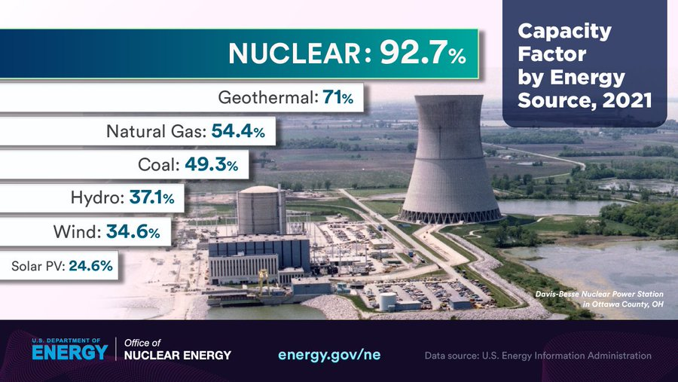
⁽⁷⁾
Grid-Level Impacts
Grid impacts from Variable GHG-Free Energy Sources may result in curtailment. Grid operators require wind and solar generators to curtail production to reduce energy output below the levels they would have otherwise produced during periods of:
- Congestion, when power lines don’t have enough capacity to deliver available energy, and
- Oversupply, when generation exceeds customer demand.

In 2022 15% of CA Renewable Power (Solar & Wind) was curtailed. California Independent System Operator

Storage technologies under development may reduce curtailment but introduce additional lifecycle greenhouse gas emissions as noted in Section 7 “Lifecycle Greenhouse Gas Emission Comparisons from Electricity Generation."

- Regional Availability of Renewable Energy Sources

“Hydropower currently accounts for 28.7% of total U.S. renewable electricity generation and provides 6.2% of total U.S. electricity generation.”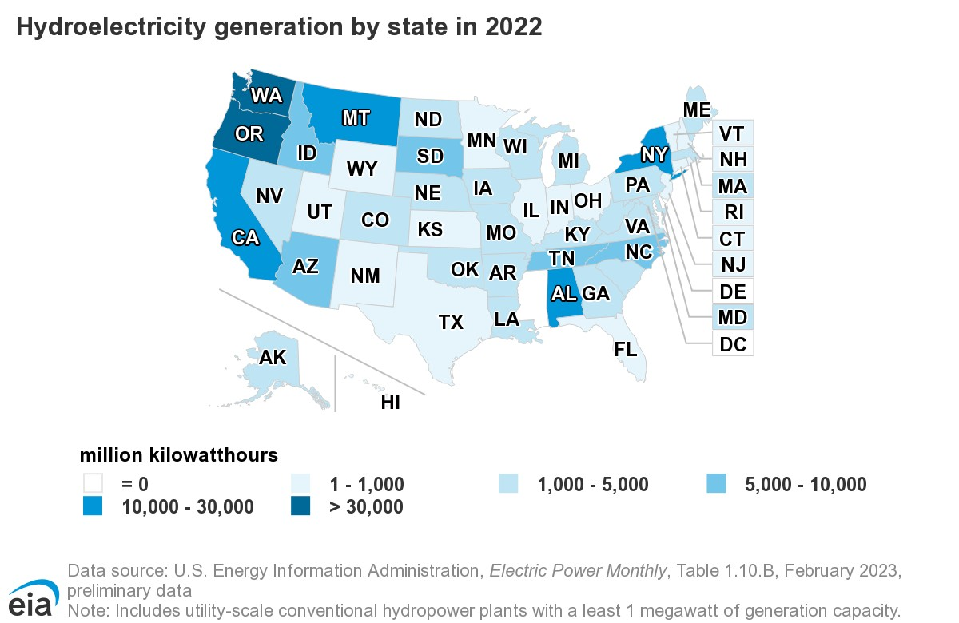
“Wind power provides 9.2% of U.S. electricity generation.”
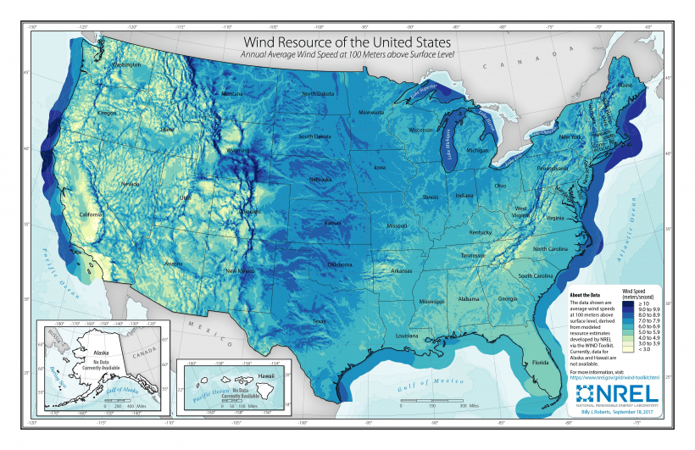
“Solar power provides 2.8% of U.S. electricity generation.”
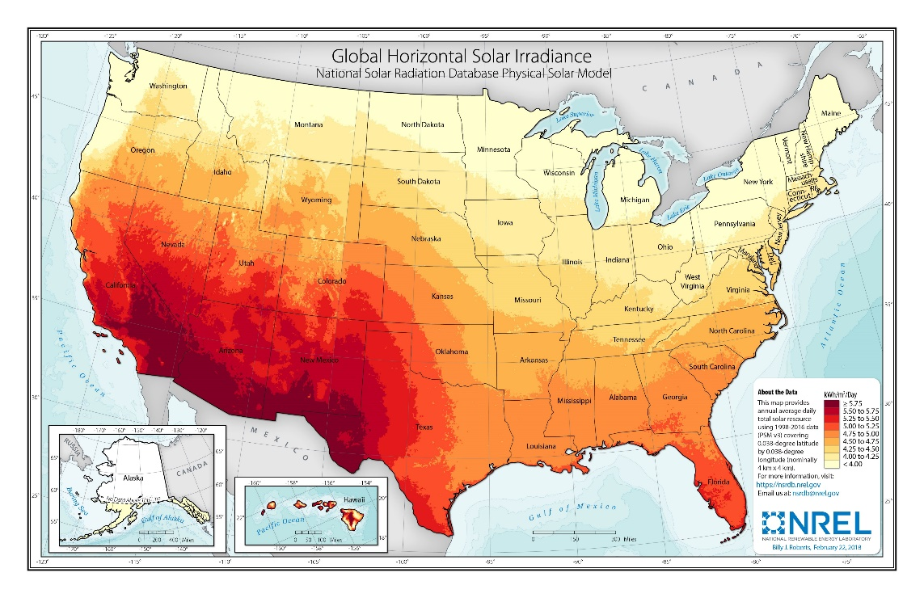 About NREL | NREL
- Grid-Level Cost Comparison of Energy Sources (Energy Technologies Institute accessed 6/14/23, https://www.eti.co.uk/)
Grid-level system cost comparisons including connection costs, transmission and distribution costs, and end-use utilization costs for systems utilizing 30% renewable energy sources were substantially greater than nuclear costs: onshore wind >5X nuclear, off-shore wind >8X nuclear, residential photovoltaic >8X nuclear, and commercial photovoltaic >10X nuclear.
- Land Use Comparison for Energy Sources

“If the total 4.05 trillion kilowatt-hours of electricity consumed in the United States 2022 were supplied by a single source of power, rather than a mixture of different technologies, this is how much land each power source would require: ⁽⁸⁾

Nuclear 469 sq. mi. 1X
Coal 23,456 sq. mi. 5X
Solar Rooftop 29,711 sq. mi. 63X
Wind 154,808 sq. mi. 330X”
- Life Cycle Greenhouse Gas Emissions from Electricity Generation
National Renewable Energy Laboratory https://www.nrel.gov/analysis/life-cycle-assessment.html)
Life cycle assessments can help quantify environmental burdens from “cradle to grave” and facilitate more consistent comparisons of energy technologies.
Generalized Life Cycle Stages for Energy Technologies
- Upstream
  - Resource Extraction
  - Material Manufacturing
  - Component Manufacturing
  - Construction
- Fuel Cycle
  - Resource Extraction
  - Production
  - Processing/Conversion
  - Delivery to Site
- Operation
  - Combustion
  - Maintenance
  - Operations
- Downstream
  - Dismantling
  - Decommissioning
  - Disposal
  - Recycling
Life cycle GHG emissions from renewable electricity generation technologies are generally less than from those from fossil fuel-based technologies, according to evidence assembled from the Life Cycle Assessments Harmonization project. Further, the proportion of GHG emissions from each lifecycle stage differs by technology. For fossil-fueled technologies, fuel combustion during operation of the facility emits the vast majority of GHGs. For nuclear and renewable energy technologies, most GHG emissions occur upstream of operation.
Median Published Total Life Cycle Emissions Factors
for Electricity Generation Technologies
Renewable grams CO₂ equivalent/Kilowatt-hour (carbon dioxide produced for same amount of power generated)
Biomass 52
Photovoltaic 43
Concentrating Solar Power 28
Geothermal 37
Hydropower 21
Ocean 8
Wind 13
Storage technology (supplements emissions for renewable sources)
Grid-scale lithium-ion battery and hydrogen fuel cell stationary storage literature compiled under the Los Angeles 100% Renewable Energy Study (Nicholson et al. 2021)
Pumped-Storage hydropower 7.4
Lithium-ion Battery 33
Hydrogen Fuel Cell 38

Non-Renewable
Nuclear 13
Natural Gas 486
Oil 840
Coal 1001

Battery Storage for Renewable Energy Critical Minerals – Topics - IEA (accessed 2-12-24)
Certain materials are particularly critical for the clean energy transition. These include lithium used in the batteries that run EVs, rare earth minerals in the magnets that allow wind turbines to make electricity, and copper, which is used for electricity transmission. Home | MIT Climate Portal
“Prices of many minerals and metals that are essential for clean energy technologies have recently soared due to a combination of rising demand, disrupted supply chains and concerns around tightening supply. The prices of lithium and cobalt more than doubled in 2021, and those for copper, nickel and aluminum all rose by around 25% to 40%.
The price trends have continued into 2022. The price of lithium has increased an astonishing two-and-a-half times since the start of the year. The prices of nickel and aluminum – for which Russia is a key supplier – have also kept rising, driven in part by Russia’s invasion of Ukraine. For most minerals and metals that are vital to the clean energy transition, the price increases since 2021 exceed by a wide margin the largest annual increases seen in the 2010s.”⁽⁹⁾

Price Increase Jan 2021 – March 2022 (%)
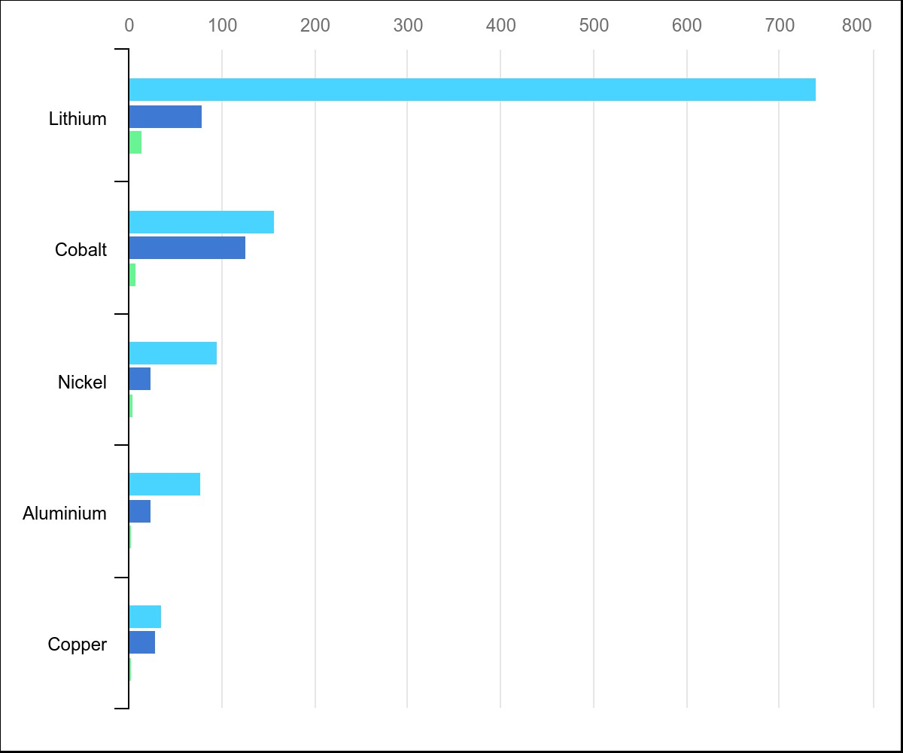

Critical minerals threaten a decades-long trend of cost declines for clean energy technologies – Analysis - IEA (accessed 2-12-24)
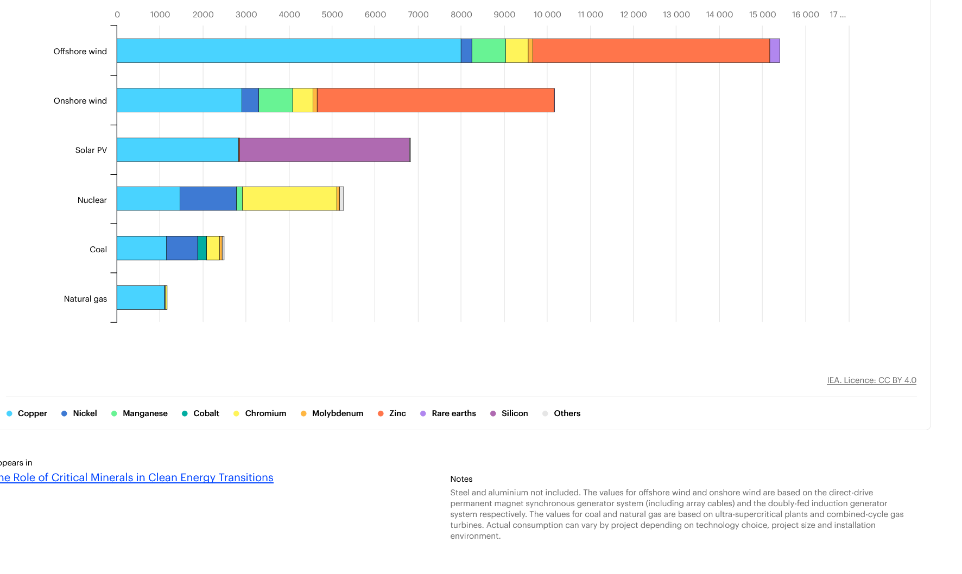

Notes
Steel and aluminum not included. The values for offshore wind and onshore wind are based on the direct-drive permanent magnet synchronous generator system (including array cables) and the doubly fed induction generator system respectively. The values for coal and natural gas are based on ultra-supercritical plants and combined-cycle gas turbines. Actual consumption can vary by project depending on technology choice, project size and installation environment.

Appears in
- The Role of Critical Minerals in Clean Energy Transitions
Mineral mining waste.
“In the U.S., copper mining produces the largest percentage of metal mining and processing waste. Waste storage piles can be as large as 1,000 acres and waste is typically stored in isolated areas called tailing ponds. Tailing Ponds may fail (especially in the face of natural hazards like floods and earthquakes), sending toxins into nearby water systems. An Associated Press report from 2019 found that more than 50 million gallons of contaminated wastewater from U.S. mines flow into local water sources every day.”⁽⁴⁾
The International Renewable Energy Agency predicts that we’ll have to deal with a cumulative 78 million metric tons of antiquated solar panel waste and tens of millions of tons of old turbine blades by 2050. U.S. DOE Assistant Secretary for the Office of Nuclear Energy Dr. Kathryn Huff recently stated, “Nuclear power plants produce no greenhouse gas emissions during operation, and over the course of its life cycle, nuclear produces about the same amount of carbon dioxide-equivalent emissions per unit of electricity as wind, and one-third of the emissions per unit of electricity when compared with solar.”⁽¹⁰⁾
- Current Discussion of Nuclear Energy’s Role in GHG Emission Reductions
The capital cost to develop new nuclear plants has increased dramatically over the past several decades, and this has reduced the interest of most utilities in pursuing new stations. The high capital cost and relatively high operating costs make nuclear power considerably more expensive than other technologies, and many utilities have elected to retire plants rather than pursue a license extension that would allow them to remain in use. The development schedule for new nuclear power stations is long relative to that for other technologies. There are also challenges associated with disposition of spent fuel from nuclear power because the Federal government has been unable to achieve a national program for permanent spent fuel disposition.
Additional domestic reductions to GHG emissions may be realized by licensing extensions to currently operating nuclear power plants. The initial NRC licensing period for domestic nuclear reactors is 40 years. Pacific Northwest National Laboratory Earth Scientist Son H. Kim calculated that, without adding any new capacity, 60-year to 80-year extensions for existing nuclear reactors could contribute to an approximate reduction of 0.4 gigatons of carbon emissions per year by 2050. Taking it one step further, with lifetime extensions of existing plants and the inauguration of new nuclear plants, the total cumulative difference in carbon-dioxide emissions between 2020 and 2100 could reach 57 gigatons of carbon emissions per year. The International Energy Agency reported U.S. carbon emissions in 2022 were 4.7 gigatons. Kim says that means nuclear energy could save about 12 years of carbon emissions.⁽¹¹⁾
During the 2023 UN COP28 Climate Change Conference 22 countries including the U.S. agreed to the goal of tripling global nuclear energy capacity by 2050 to achieve “global net-zero greenhouse gas/carbon neutrality by or around mid-century and in keeping a 1.5 degrees Celsius limit on temperature rise within reach." The U.N. Intergovernmental Panel on Climate Change indicated that the world’s total renewable energy will be insufficient to meet global energy needs. Although the potential energy from these sources exceeds the world’s current and future energy needs many times, that does not mean that renewable sources will provide all the needed energy as geographic availability is a major constraint. All low-carbon energy sources have other implications for people and countries. Some of them are desirable, for example, reducing air pollution or making it easy to provide electricity in remote locations. However, some of them are undesirable, for example decreasing biodiversity or ecological damage caused by mining minerals to produce low emissions technologies.⁽²⁾

References
- US Energy Information Administration Website, Accessed 29 October 2023. Use of energy explained - U.S. Energy Information Administration (EIA)
- “Mitigation of Climate Change,” Intergovernmental Panel on Climate Change 6th Assessment Report , WGIII, Frequently Asked Questions, Accessed October 2023 Frequently Asked Questions (ipcc.ch)
- “On the Path to 100% Clean Energy,” US Department of Energy Office of Nuclear Energy, May 2023, Page 5.
4.“World Nuclear Performance Report 2022,” Page 20. https://www.world-nuclear.org/climate-change-and-nuclear-energy/world-nuclear-performance-report-
5. “Meeting Climate Change Targets: The Role of Nuclear Energy,”, p.22. Nuclear Energy Agency, OECD (2022).

6. Capacity Factor Definition, https://nuclear.duke-energy.com/2015/02/18/capacity-factor-a-measure-of-reliability Duke Energy website, Accessed 9 November 2023.
7. “Capacity Factor by Energy Source 2021,” DOE Graphic, Accessed 7/21/22. www.doe.gov
8. Washington Post, Harry Stevens, May 10, 2023.
9. Tae-Yoon Kim, World Energy Organization Analyst, May 18, 2022, www.iea.gov
10.Testimony of Dr. Kathryn Huff, Assistant Secretary, US Department of Energy Office of Nuclear Energy, and Ms. Kelly Speakes-Backman, Principal Deputy Assistant Secretary for Energy Efficiency and Renewable Energy, U.S. Department of Energy before the Committee on Energy and Natural Resources, U.S. Senate July 28, 2022.
11. John Kosowatz, “Nuclear Energy’s Role in Climate Change is Quantified” ASME Energy Blog, May 17, 2023.

