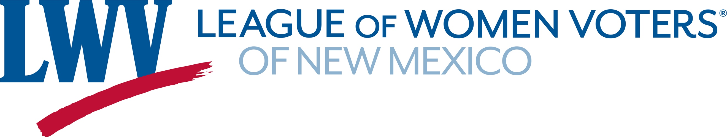

Legislative Priorities for Voting, Elections & Ethics 2025

The League of Women Voters of New Mexico advocates for an all-inclusive system of voting that allows all registered voters to participate in the primary election so that voters who are not enrolled in a major political party may vote on one ballot per primary without having to enroll in that particular party. The League supports consolidation of elections in New Mexico and verifiable and auditable procedures to guarantee the integrity of all statutory methods of voting in New Mexico

LWVNM supports:
SB16 Non- Major Party Voters in Primary Elections Senator Figueroa
This bill would allow Declined to State (DTS) and those registered with minor parties to select the ballot of a major party without changing their voter registration designation. The bill does not allow those registered in a major party to select the ballot of another major party.

SB218 Election Changes Senator Duhigg
This bill includes updates to our election codes to address issues that have arisen in past elections.
In addition it moves all remaining nonpartisan local elections to November of odd number years.
The League believes in strong ethics rules and financial reporting requirements, ensuring maximum transparency in government at all levels.
LWVNM supports:
SB85 Campaign Finance Changes Senator Wirth
Updates our current campaign financing law to make it more effective and to conform to recent court rulings.

The League supports legislative compensation that is fair and reasonable, recognizing that there is a cost to government and that the cost should be paid by the taxpayers of New Mexico.

LWVNM supports:
SJR1 Salary Commission – Constitutional Amendment Senators Figueroa & Wirth
If passed by the both chambers of the Legislature, this resolution would go on the ballot in the next general election. If passed by the voters, it would amend article 4 of the constitution of NM to create a Citizens’ Commission on Legislative Salaries to establish, adjust and limit salaries of members of the Legislature and would amend section 10 to authorize payment of legislative salaries.

Contact: Dick Mason 505-239-3804 dickmasonnm@gmail.com
Hannah Burling 505-603-1601 hannahburling@gmail.com

