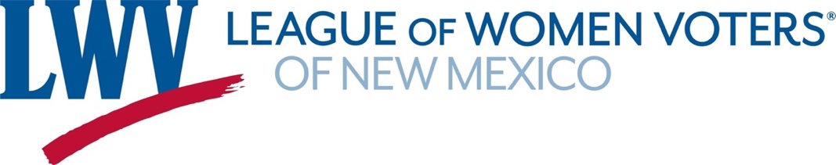

**Legislative Priorities for Social Policy 2025**

***The LWVNM supports regulation of firearms for public safety.***

***The League of Women Voters of New Mexico supports sufficient funding for a high-quality equitable educational system for all students that is consistently and fairly applied across the state.***

**HB63 Public School Funding Formula Changes Rep. A Romero/Sen. Stewart**

Formula adjustments to the State Equalization Guarantee will provide schools with supplemental funding for students who are challenged by high poverty, learning disabilities, language differences, and other factors. NM must provide programs and services to address the needs of students who are not receiving a sufficient education in order to comply with the Yazzie-Martinez court order.

**SB64 School Career Development Success Sen. Brant/Rep. Gurrola**

This bill will establish a three-year pilot program administered by the Public Education Department to provide financial incentives to school districts whose students earn industry-recognized credentials.

**SJR3 State Board of Education, CA Senator Soules**

This Constitutional amendment resolution aims to establish a State Board of Education, which will appoint an education secretary, determine educational policies, and oversee funding and accountability of school districts and charter schools. Once passed by both chambers, the measure goes to voters for approval in the next general election.

**HB11 Paid Family Medical LeaveReps. Chandler, Roybal-Caballero, Serrato**

This bill aims to establish a state insurance policy that would allow eligible individuals up to 12 weeks of parental leave and 9 weeks for paid medical leave for qualifying conditions. Workforce Solutions will manage the PFML Trust Fund program for most workers in the state. Businesses that provide benefits equal to PFML standards can get waivers. The bill requires employee contributions of 0.5 percent and employer contributions of 0.4 percent of wages.

LWVUS signed onto a letter with 340 other organizations in support of HB 11.

**HB 12 Extreme Risk Protection Order Changes Representatives Chandler & Garratt**

This bill strengthens NM's 2020 ERPO law by allowing law enforcement, licensed health care providers, and family members to petition a court to order relinquishment of firearms from a person in danger of injuring self or others.

**HB 38 Possession of Weapon Conversion Device Representatives Cates & Little**

This bill aims to restrict the sales and possession of devices that convert firearms into assault weapons and bring NM in compliance with federal standards so that NM's law enforcement can implement the standards.

**Contact: Meredith Machen projects@lwvnm.org 505 577-6337**