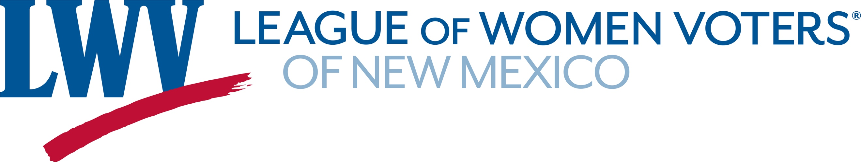
Legislative Priority for Redistricting Reform 2025
The League of Women Voters of New Mexico believes that responsibility for redistricting should be vested in an independent redistricting commission with membership that reflects the diversity of the population. LWVNM supports a redistricting process and standards that provide the people with a meaningful choice in electing their representatives and facilitate holding government accountable.
LWVNM supports:
HB121 County Redistricting Act Representative Cates
This bill would mandate independent redistricting commissions in Class A Counties.
Currently that would apply to San Juan, Santa Fe, Sandoval, Bernalillo and Dona Ana Counties.
Why we need it:
There is an inherent conflict of interest in office holders designing their own districts.
In 2021, the Navajo Nation brought a lawsuit against the San Juan County Commission alleging a violation of the Federal VRA Act. The suit charged that in drawing new districts, the San Juan County Commission deprived the Navajo Nation of the opportunity to elect a commissioner that represented their community. The lawsuit was settled and the Navajo Nation gained a seat on the Commission.
In 2021, a lawsuit was brought by the Sandoval Democratic Party, the Pueblo of San Felipe, and various individuals alleging a violation of the New Mexico Constitution; the New Mexico Civil Rights Act, NMSA 1978, Section 41-4A-1 et. seq; and Sandoval County Ordinance Sec. 2-21. They charged that in drawing new county districts, the Sandoval County Commission deprived Native Americans and Hispanics the opportunity to elect a commissioner of their choice. That suit is still pending.

Contact: Dick Mason 505-239-3804 dickmasonnm@gmail.com

