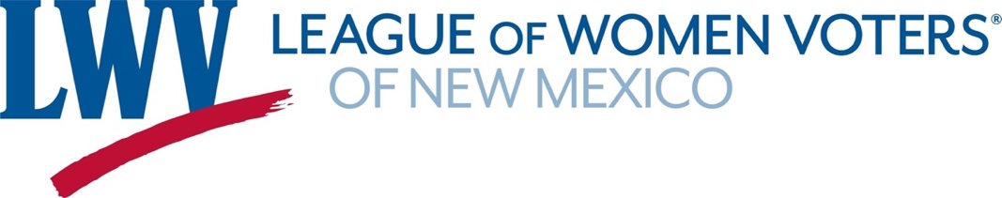

**Legislative Priorities for Affordable Housing 2025**

***The League of Women Voters of New Mexico supports current and future efforts to increase the availability of safe, decent, and affordable housing for moderate and low income households through the following actions:***

1. ***Increase housing options for households in New Mexico, including but not limited to seniors, the disabled, and first-time homebuyers.***
2. ***Promote a variety of housing styles and types for rent and for purchase that are integrated within communities.***
3. ***Support strategies including public and private partnerships and grants, developmental agreements, rehabilitation, fee waivers, density bonuses, and an affordable housing trust fund and land bank.***
4. ***Support policies that link transportation, land use, and affordable housing.***

**LWVNM supports:**

**SB144 Affordable Housing Act Funding Senator Gonzales**

Makes an appropriation ($500K) to carry out the Affordable Housing Act.

**SB145 Housing Trust Fund Senator Gonzales**

Makes an appropriation ($500M) to the Housing Trust Fund with a 10% set aside for Local Municipalities and Counties.

**SB205 State Office of Housing Planning & Production Senator Gonzales, et al.**

Creating a State Office of Housing Planning and Production providing powers & duties

**HB114 Ban Discriminatory Restrictive Covenants Representative Chavez**

Prohibits the submission or declares void existing discriminatory restrictive covenants or gender-specific language regarding real property.

**Contact information:**  Janie McGuigan 505-918-1884 (cell) janiemc07@gmail.com