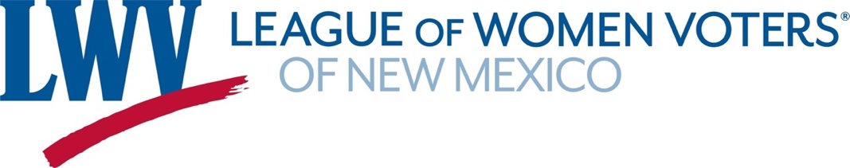

**Legislative Priorities for Health Care 2025**

***LWVNM believes that every New Mexico resident should have a comprehensive level of health care. with “seamless” coverage and simplified administration.***

***Cost and pricing data from private and government sources should be transparent.***

***No one should be forced into poverty because of medical needs.***

**LWVNM supports:**

**HB15 Health Care Strategic Recruitment Plan Representative Anaya**

Creates a Health Care Strategic Recruitment Program in the Workforce Solutions Department.  
Provides services for qualified health care providers in health care shortage fields.

**HB186 State Administered Health Coverage Plan Representative Szczepanski**  
This bill would allow individuals who do not meet the federal qualifications for Medicaid to buy into the state Medicaid program on a sliding scale.

**SB14 Health Care Consolidation & Transparency Act Senator Duhigg**

Provides Oversight of acquisitions, mergers, affiliations and other transactions that involve indirect changes of control or assets of hospitals & other health care entities.

**SB1 Behavioral Health Trust Fund Senator Munoz**

This along with SB2 (Senator Shendo) and SB 3 (Senator Wirth) are aimed at rebuilding  
our behavioral health care system that was dismantled by executive order in 2013.  
 **SB46 Interstate Medical Licensure Act Senator Linda Trujillo**  
This would have New Mexico join the Interstate Medical Licensure Compact, which facilitates doctors licensed in other states to become licensed in states that are members of the Compact. This is just one of the interstate licensing compacts the League will be supporting

**SB88 Medicaid Trust Fund & State Supported Fund Senators Munoz & Sharer**

Creates the Medicaid Trust Fund & the State Supported Medicaid Fund. Provides various mechanisms for transfers into these funds. These funds could be key should there be changes in federal support for Medicaid.

**Contact information:** Akkana Peck healthcare@lwvnm.org  
 Dick Mason 505-239-3804 dickmasonnm@gmail.com