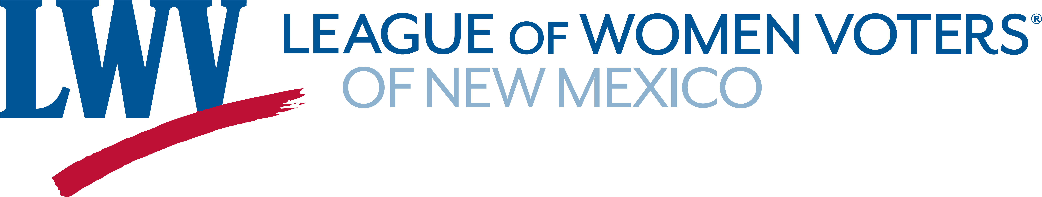
Legislative Priorities for Environment 2025

The League believes that the state, water regions, and local governments must preserve and restore rivers and watersheds.
LWVNM supports:
SB 37 Strategic Water Reserve Fund Senator Stefanics

The League supports stringent regulations to protect ground and surface water quality from pollution that can impact human health as well as the natural flora and fauna and believes that such regulations must be strictly enforced.
LWVNM supports:
SB 21 and 22 Water Quality and Pollution Senator Wirth

The League supports policies and incentives that reduce greenhouse gas emissions by promoting greater energy efficiency and by developing clean, renewable energy sources.
LWVNM supports:
SB 4 Clean Horizons and Greenhouse Gas Emissions Senator Stewart
HB 51 Energy Storage System Income Tax Credit Representative Sariñana

The League believes that the State Legislature should ensure that the State Land Commissioner has the support needed to maximize profits and minimize administrative costs, while protecting the environment and preserving the long-term value of the land.

LWVNM supports:

SB 23 Increase Oil and Gas Royalties Senator Muñoz

The League supports rigorous regulation and enforcement to prevent mining and drilling activities from contaminating surface or ground water or the surrounding landscape

LWVNM supports:

HB 222 Fracking Fluid Rep. Andrea Romero
SB 9 Pipeline Penalties Senator Soules

The League supports the conservation and protection of wildlife and their habitats for the contribution they make toward the health and sustainability of the environment.
LWVNM supports:
SB 5 Game Commission Reform Senator Campos

State government and the legal process must work to reconcile the many claims on New Mexico water in a manner that is open and as fair as possible.
LWVNM supports:
SB 185 Unlawful Use of Underground Water Senator Townsend
SB 210 Increase Penalty for Violation Senator Campos

Contact Information:
Barbara Calef (505) 205-5705 bfcalef@gmail.com
Jeanne Logsdon (505) 710-3886 jlogsdon@unm.edu

