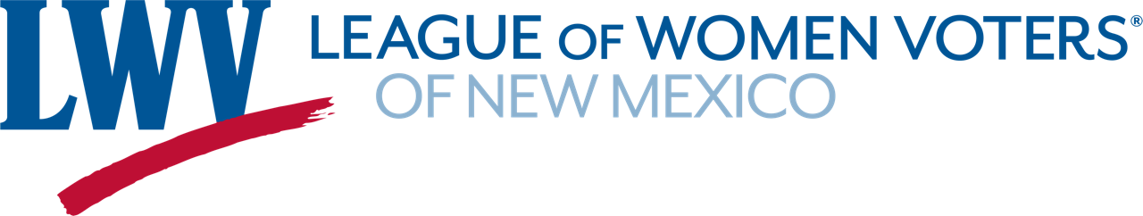
January 4, 2025 Advocacy Workshop – 10am to noon
Agenda
Opening & Welcome: Hannah Burling, LWVNM co-President
Introduce panelists
Review the format – remind not about issues, only process
Review the documents available on our website (see below)
Linda Siegle – Professional lobbyist
Review the Legislative process during a 60 day session
Talk about how she interacts with legislators
Senator Carrie Hamblen – Senate District 38
Discuss how advocates can be effective and how to effectively communicate with her
and other legislators
Representative Rebecca Dow – House District 38
Discuss how advocates can be effective and how to effectively communicate with her
and other legislators
Questions & Answers from attendees – moderated by Hannah Burling
We have found in the past that the interaction between the panelists adds to the workshop.
Please feel free to interact with one another.
Documents on the League of Women Voters of NM website:
How to find a Legislator
Tips for Testifying
Using the New Mexico Legislative website
Senator Wirth’s Top Ten – his tips on effective advocacy
Senator Hamblen’s tips

