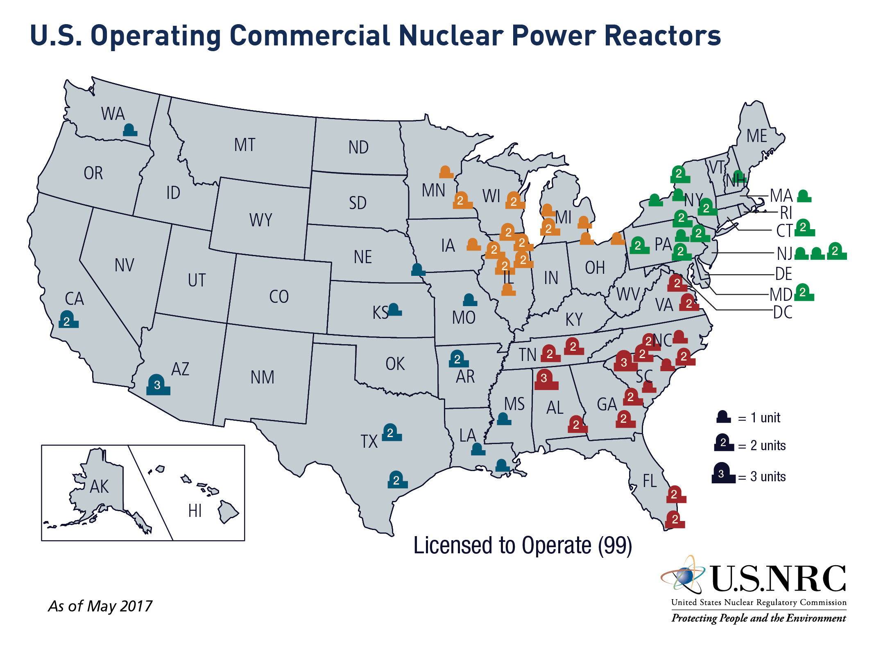

Pellet, fuel

A thimble-sized ceramic cylinder (approximately 3/8-inch in diameter and 5/8-inch in length), consisting of [uranium](https://www.nrc.gov/reading-rm/basic-ref/glossary/uranium.html) (typically uranium oxide, UO2), which has been [enriched](https://www.nrc.gov/materials/fuel-cycle-fac/ur-enrichment.html) to increase the concentration of uranium-235 (U-235) to fuel a [nuclear reactor](https://www.nrc.gov/reading-rm/basic-ref/glossary/reactor-nuclear.html). Modern [reactor cores](https://www.nrc.gov/reading-rm/basic-ref/glossary/reactor-core.html) in [pressurized-water reactors (PWRs)](https://www.nrc.gov/reading-rm/basic-ref/glossary/pressurized-water-reactor-pwr.html) and [boiling-water reactors (BWRs)](https://www.nrc.gov/reading-rm/basic-ref/glossary/boiling-water-reactor-bwr.html) may contain up to 10 million pellets, stacked in the [fuel rods](https://www.nrc.gov/reading-rm/basic-ref/glossary/fuel-rod.html) that form [fuel assemblies](https://www.nrc.gov/reading-rm/basic-ref/glossary/fuel-assembly-fuel-bundle-fuel-element.html).

# Fuel rod

A long, slender, zirconium metal tube containing [pellets](https://www.nrc.gov/reading-rm/basic-ref/glossary/pellet-fuel.html) of [fissionable material](https://www.nrc.gov/reading-rm/basic-ref/glossary/fissionable-material.html), which provide fuel for [nuclear reactors](https://www.nrc.gov/reading-rm/basic-ref/glossary/nuclear-reactor.html). Fuel rods are assembled into bundles called [fuel assemblies](https://www.nrc.gov/reading-rm/basic-ref/glossary/fuel-assembly-fuel-bundle-fuel-element.html), which are loaded individually into the [reactor core](https://www.nrc.gov/reading-rm/basic-ref/glossary/reactor-core.html).

