Radiation Exposure www.nrc.gov December 2020

Time, Distance, and Shielding
Time, distance, and shielding measures minimize your exposure to radiation in much the same way as they would to protect you against overexposure to the sun (as illustrated in the figure below):
- Time: For people who are exposed to radiation in addition to natural background radiation, limiting or minimizing the exposure time reduces the dose from the radiation source.
- Distance: Just as the heat from a fire is less intense the further away you are, so the intensity and dose of radiation decreases dramatically as you increase your distance from the source.
- Shielding: Barriers of lead, concrete, or water provide protection from penetrating radiation such as gamma rays and neutrons. This is why certain radioactive materials are stored under water or in concrete or lead-lined rooms, and why dentists place a lead blanket on patients receiving x-rays of their teeth. Similarly, special plastic shields stop beta particles, and air stops alpha particles. Therefore, inserting the proper shield between you and a radiation source will greatly reduce or eliminate the dose you receive.
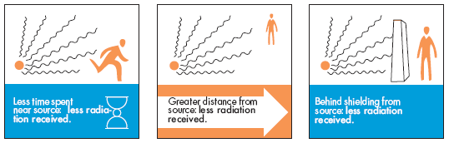

Containment
Radioactive materials are confined in the smallest possible space and kept out of the environment. Radioactive isotopes for medical use, for example, are dispensed in closed handling facilities, while nuclear reactors operate within closed systems with multiple barriers which keep the radioactive materials contained. Rooms have a reduced air pressure so that any leaks occur into the room and not out of it.

NRC's System of Radiation Protection
Over many decades, the U.S. Nuclear Regulatory Commission (NRC) has developed a system of radiation protection that reflects the world's improved understanding of the effects of radiation. In particular, the NRC ensures that users of radioactive materials keep radiation exposures within the agency's specified dose limits and as low as reasonably achievable. In addition, users must obtain a license from the NRC and be inspected to ensure that they are following the agency's regulations and safely using radioactive materials.
The NRC's system includes regulations for the following aspects of radiation protection:
- Dose limits for radiation workers and members of the public
- Monitoring and labeling radioactive materials
- Posting signs in and around radiation areas
- Reporting the theft or loss of radioactive material
In addition, the NRC imposes penalties for failures to follow the agency's regulations.
To keep radiation exposures as low as reasonably achievable, the NRC requires licensees to use radioactive materials in a way that limits the exposure of individual members of the public to a dose that does not exceed 0.1 rem (100 millirems) in a year. In addition, adults working with radioactive material must be protected so that they do notreceive more than 5 rems (5,000 millirems) per year. Because workers are exposed to various radiation sources, they are carefully monitored with the use of small instruments called dosimeters.
If certain conditions are met, the NRC may enter into an agreement with a State governor to give the State authority for regulating radioactive materials. States that meet these conditions and agree to regulate materials using the same standards as the NRC are called Agreement States. Typically, Agreement States regulate all sources of radiation in the State except nuclear power plants, large quantities of certain nuclear material, and any high-level radioactive waste stored in the State. Currently, 35 states have such agreements with the NRC.
Page Last Reviewed/Updated Friday, March 20, 2020

